Programming Fundamental

Final Phase

Rehana Hassan 22F-3819 Abdul Basit 22F-3834

  Sehar Saleem 22F-3820

Output Snaps

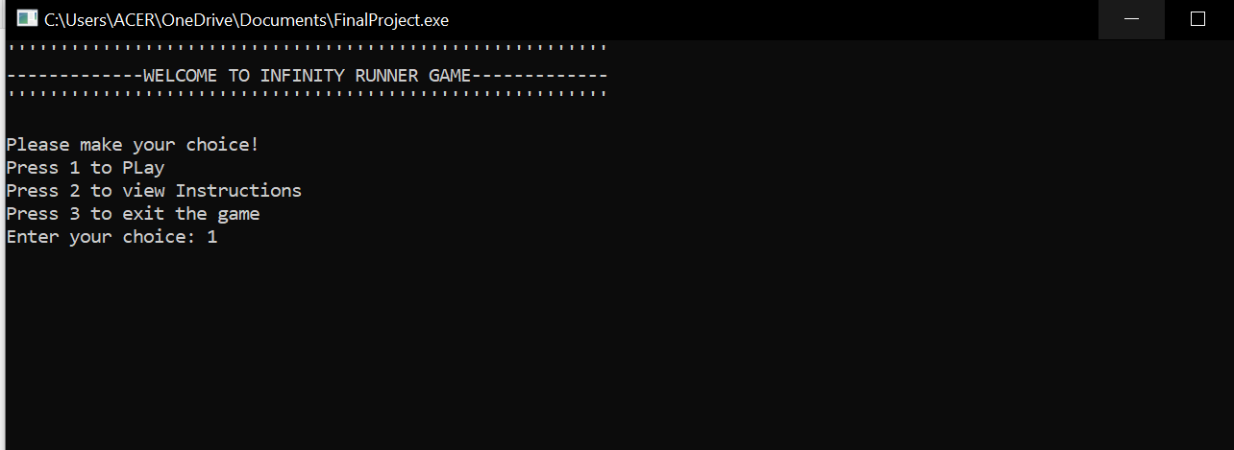

Running Form 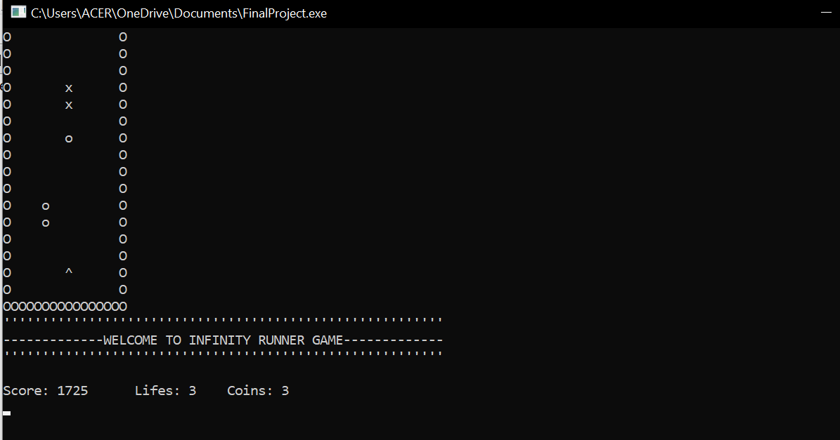

*Player Chaser*

*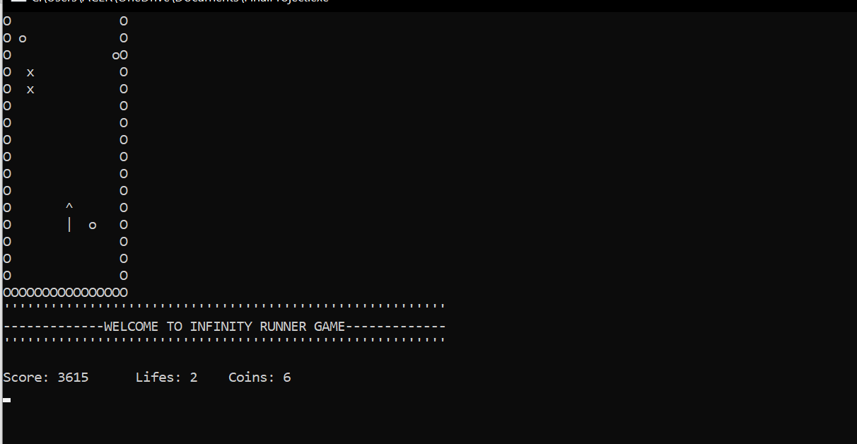*

*Game over*

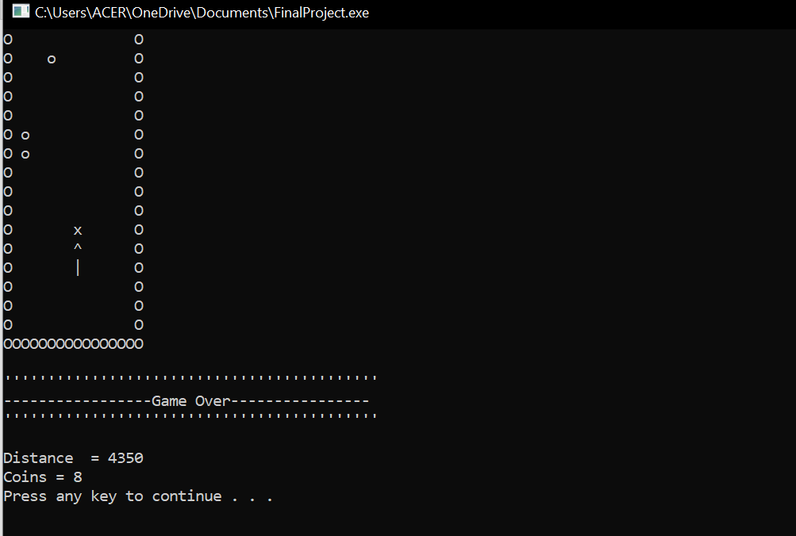

*Instructions*

